# Lab Access Instructions for Packt Customers

The customers who have bought this course through Packt or its partner platforms, please follow the steps given below to enrol for the Docker labs on the KodeKloud website.

1. For user who are accessing the KodeKloud website for the first time, sign-up to create your account at <https://kodekloud.com/> and follow step 2. The users who have an account with KodeKloud already can directly sign-in and follow step 2.
2. Please click the following link: <https://learn.kodekloud.com/user/courses/packt-labs-docker-for-the-absolute-beginner>, and then click the button **‘Enroll for free**’ as shown in the screenshot below to get started with the Docker labs.  
     
   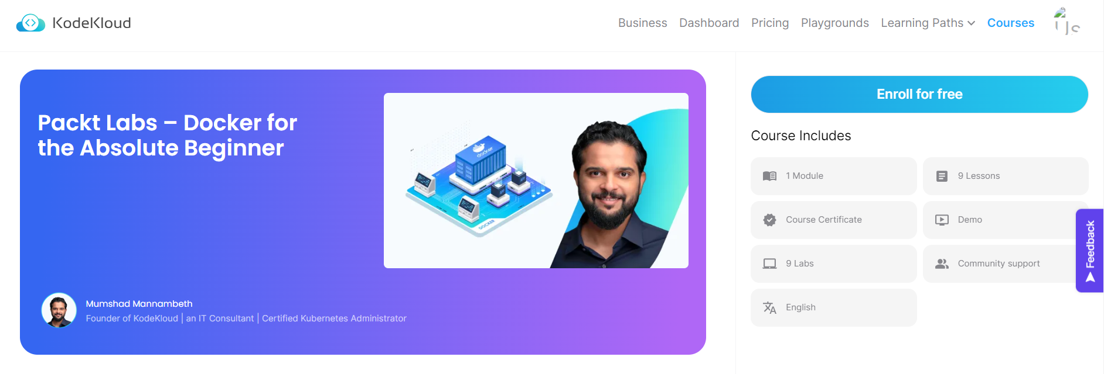
3. Another approach to access the Docker labs is to head over to the [Packt GitHub resources](https://github.com/PacktPublishing/Docker-for-the-Absolute-Beginner---Hands-On/tree/master) for this course and refer to the text documents prefixed with the name **‘Labs’** in respective section folders to get the direct link to the lab environment on KodeKloud.

Happy learning!